Crazy for Containers

Name ______________________________ Address __________________________
Phone ______________________________ _________________________________
Email ______________________________

Large Collections (16” - 9 plants) Small Collections (12” - 6 plants)

Name S/PS/Sh # Name S/PS/S #
Fern Moon | Shade | $54
Freya | Shade | $54
Limelight | Sun | $54
Sunkissed | Sun | $54

Total Small Collection ___ x $54 = ____

Alabama Sunset | Sun/PS | $68
Made in the Shade | Shade/PS | $68
Kaleidoscope | Sun | $68
Argentea | Sun | $68
Cardoon | Sun | $68
Endless Summer | Shade/PS | $68
Lavender Haze | Shade | $68
Made Shady | Shade | $68
Purple Cloak | Sun | $68

Total Large Collection ____ x $68 = ____

9-Plant Collections
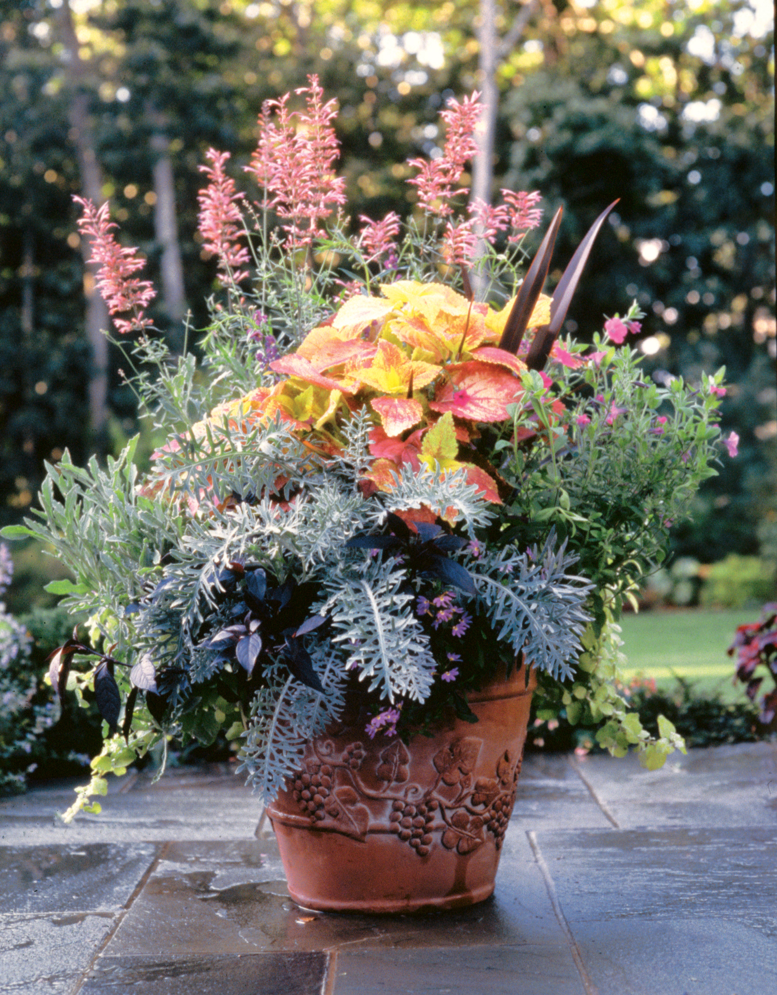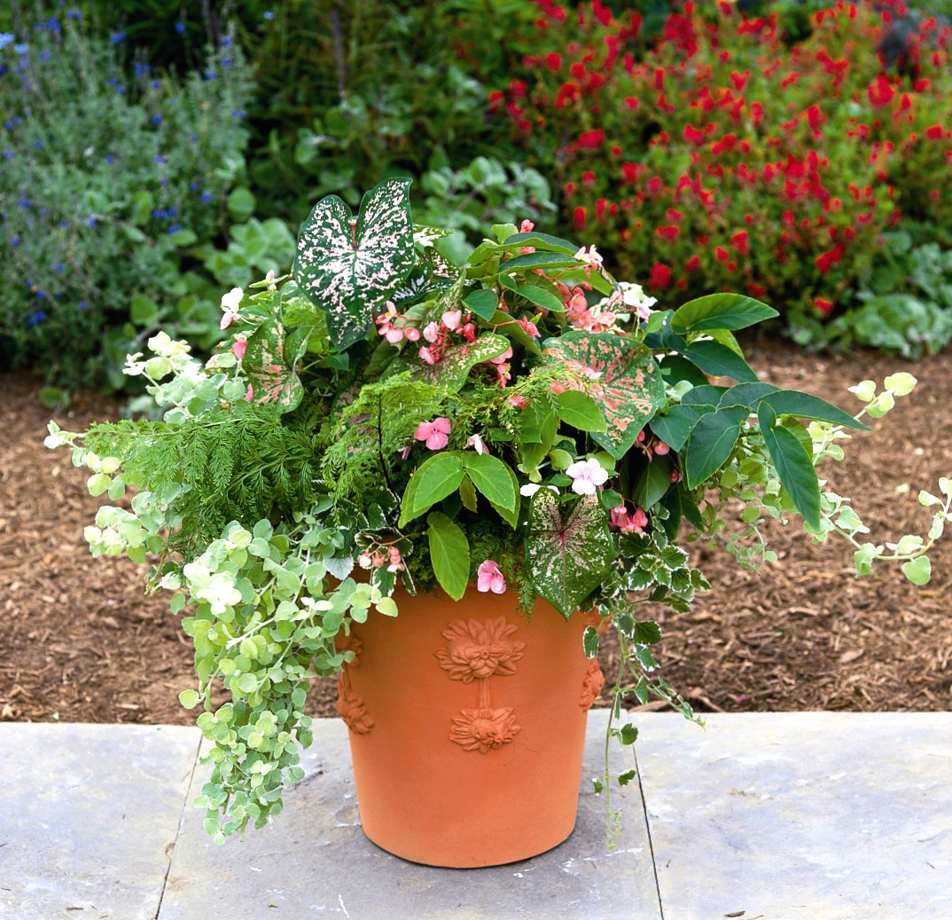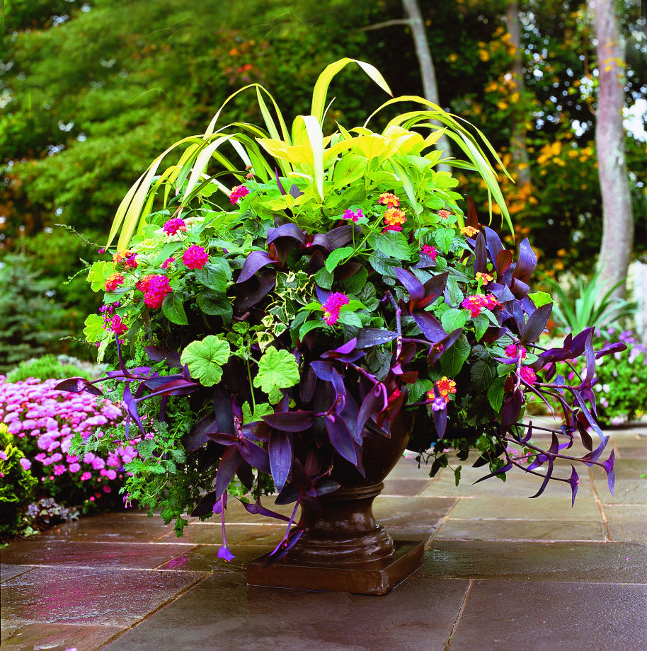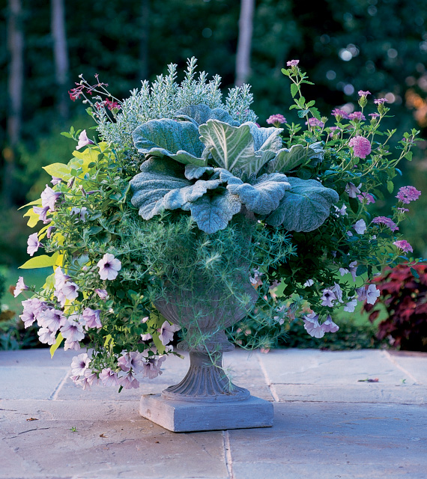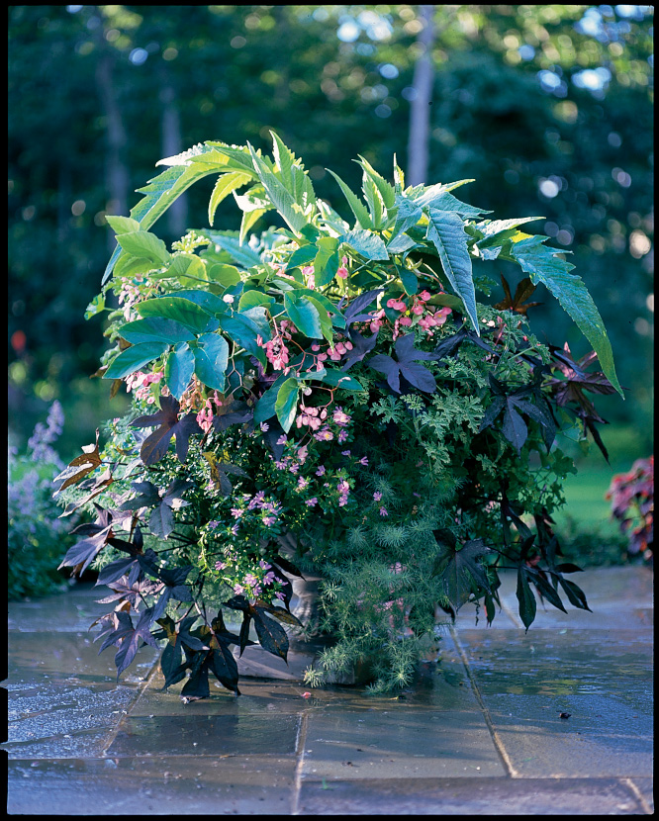
Alabama Sunset Made in the Shade Kaleidoscope Argentea Cardoon

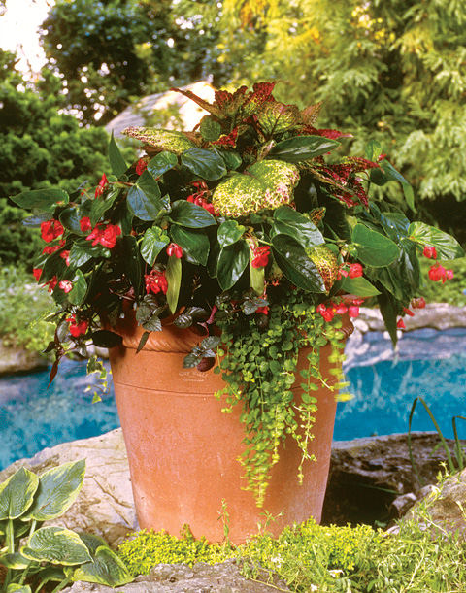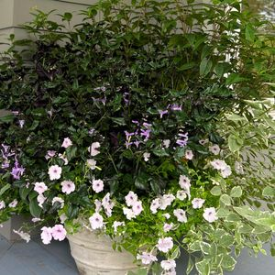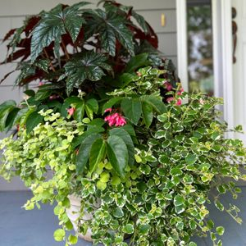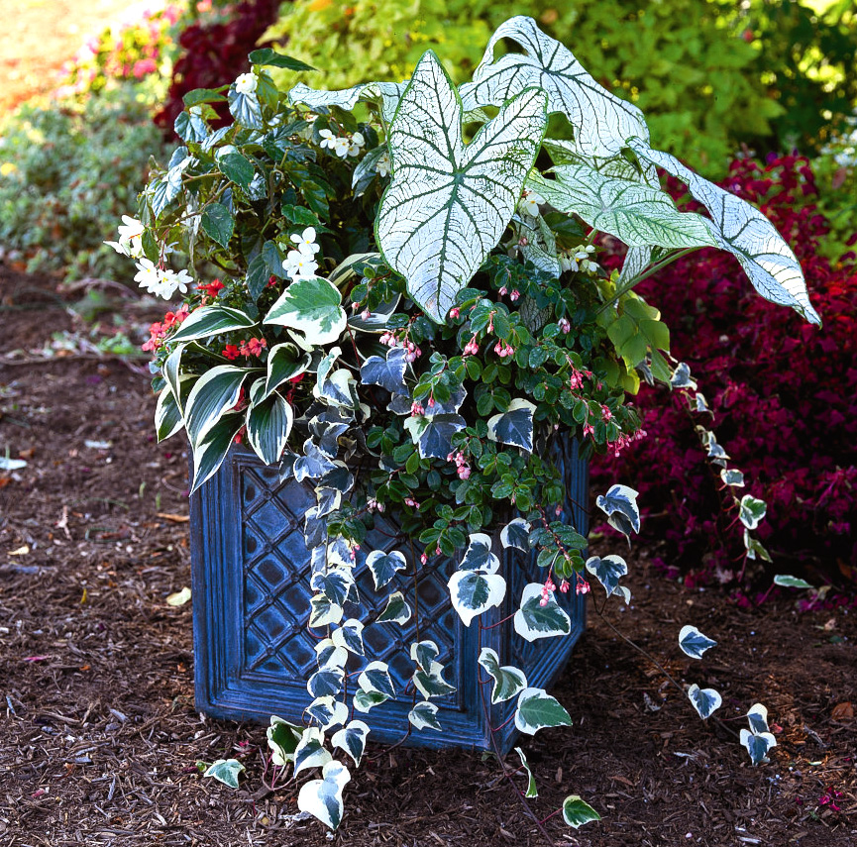
Endless Summer Lavender Haze Made Shady Purple Cloak

6-Plant Collections
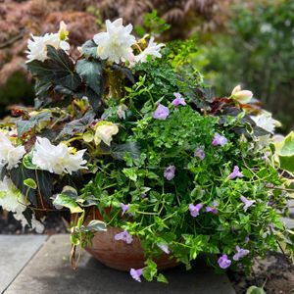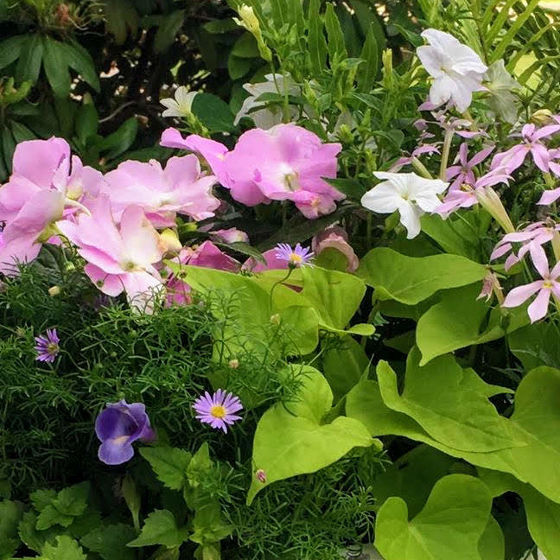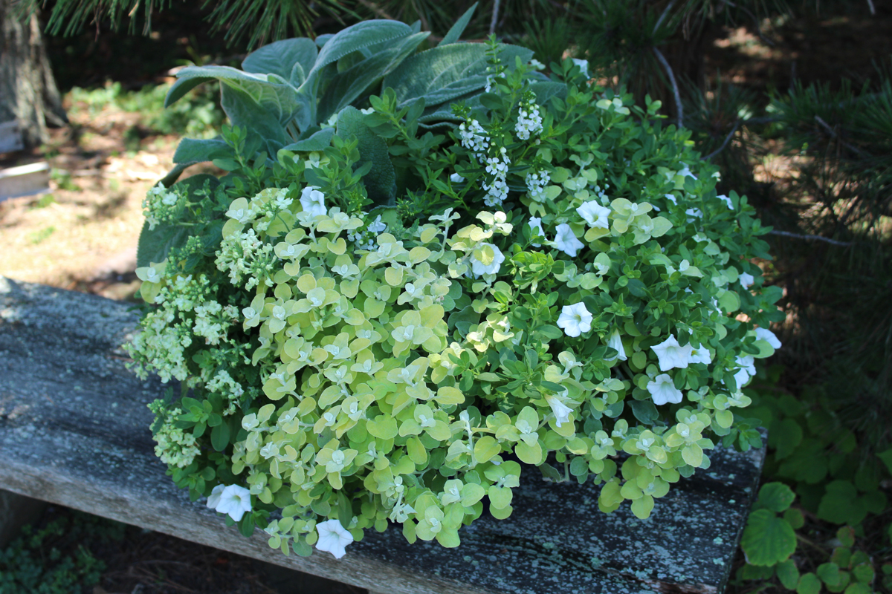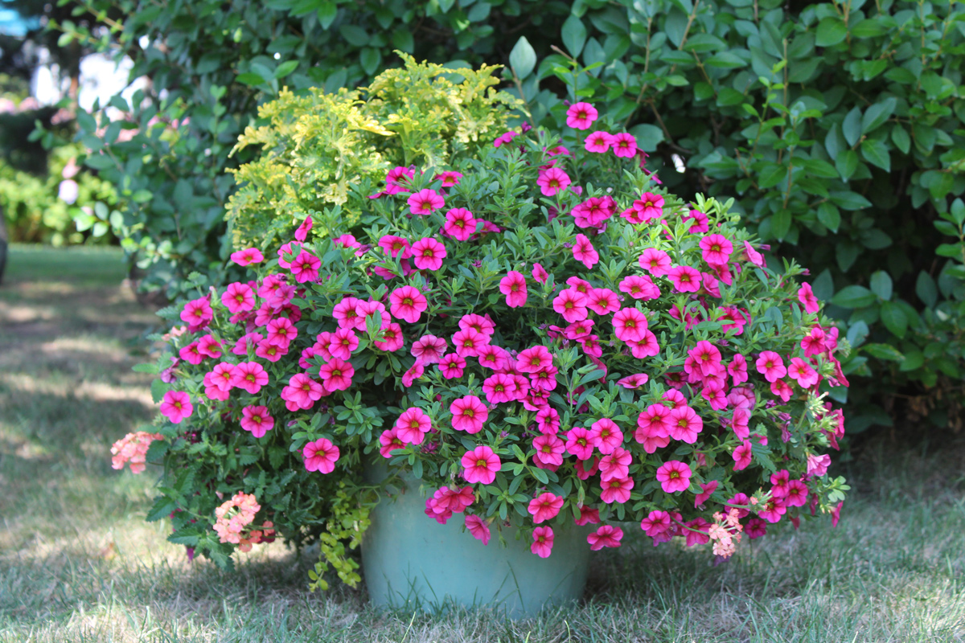
Fern Moon Freya Limelight Sunkissed
Already Potted Collections
Ready-to-go in a brown plastic decorative pot

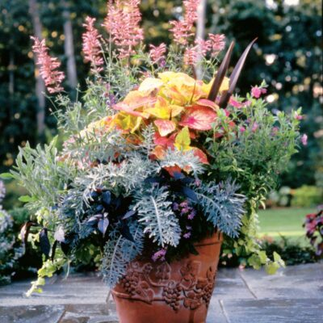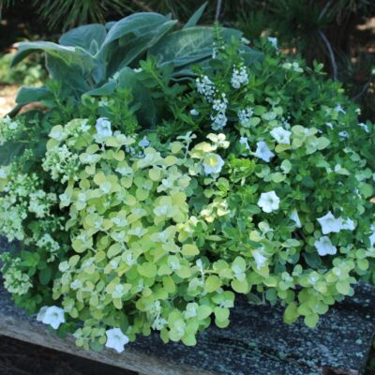
Made Shady Alabama Sunset Limelight Fern Moon
16" Pot - 16” Pot - $80 12” Pot - $60 12" Pot -
#
Total - Already Potted Collections
16" Pot ___ x $ = _____
12" Pot ___ x $ = _____
Made Shady | Shade | $
Alabama Sunset | Sun
Limelight | Sun
Fern Moon | Shade

14-inch Basket 12-inch Basket
Name S/PS/Sh # Name S/PS/Sh #
Appalachian Trails | Sun | $45
Bombay Hook | Sun | $45
Denali | Sun | $45
Petra | Shade | $45
Sedona | Sun | $45
Zion Pink | Sh-PS

Adventurine | Sun | $60
Blue Lagoon | Shade
Riptide | Shade
Spring Meadow | Sun
Sun Showers | Sun
Trade Winds | Sun
Twilight | Sun

Total 14” Basket ____ x $60 = _____ Total 12” Basket ____ x $45 = _____

14” Baskets
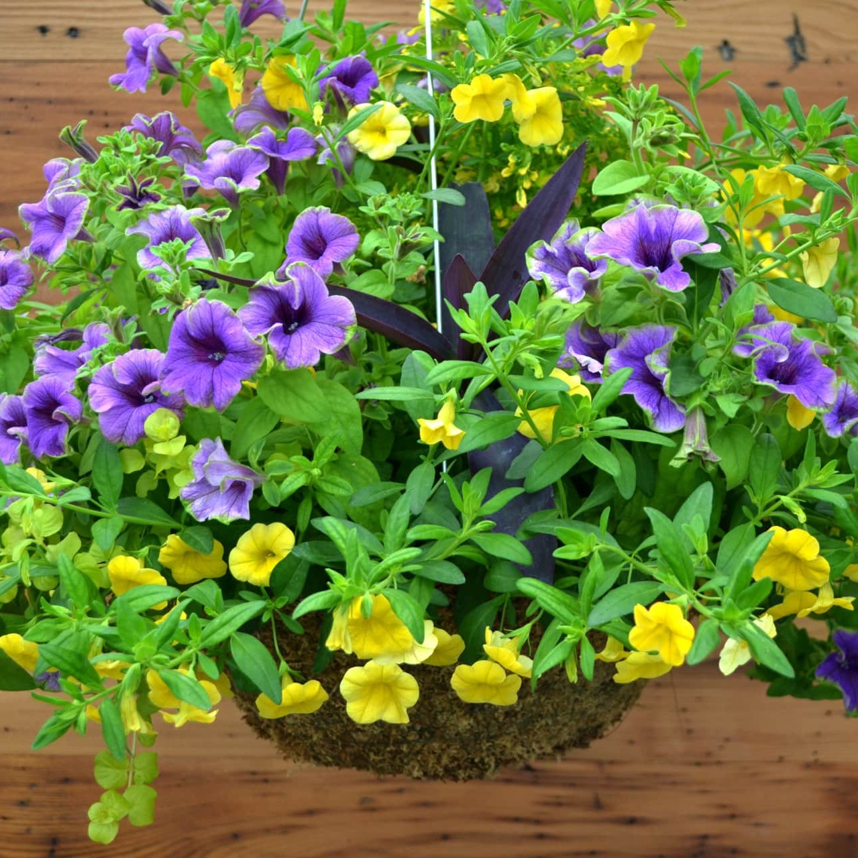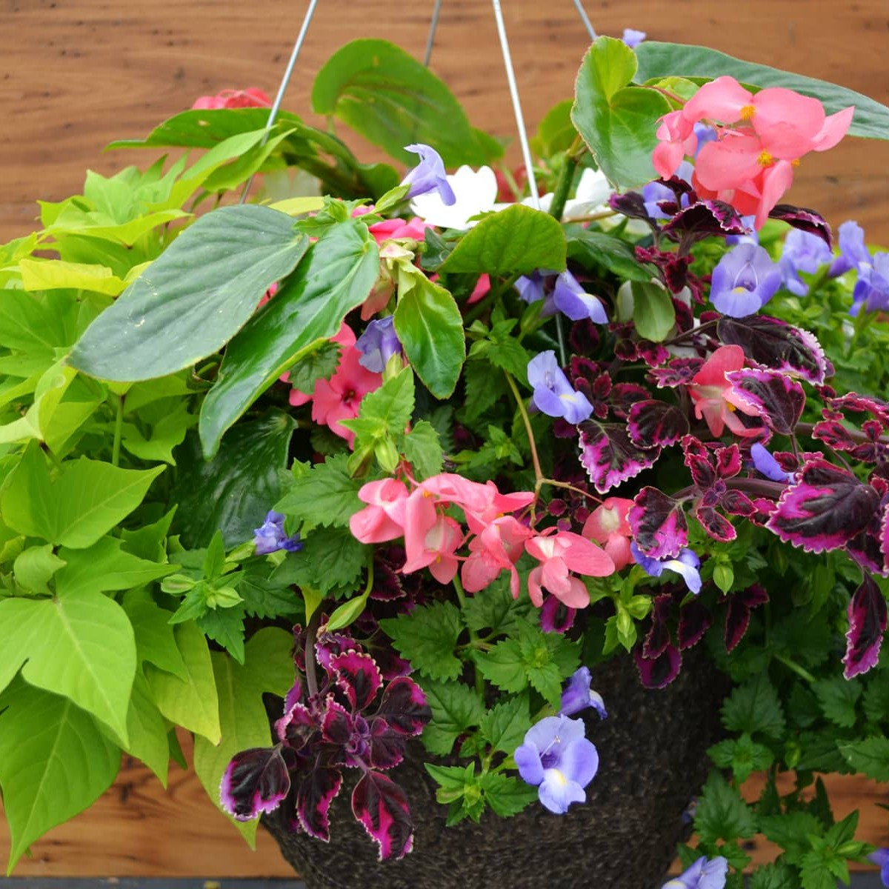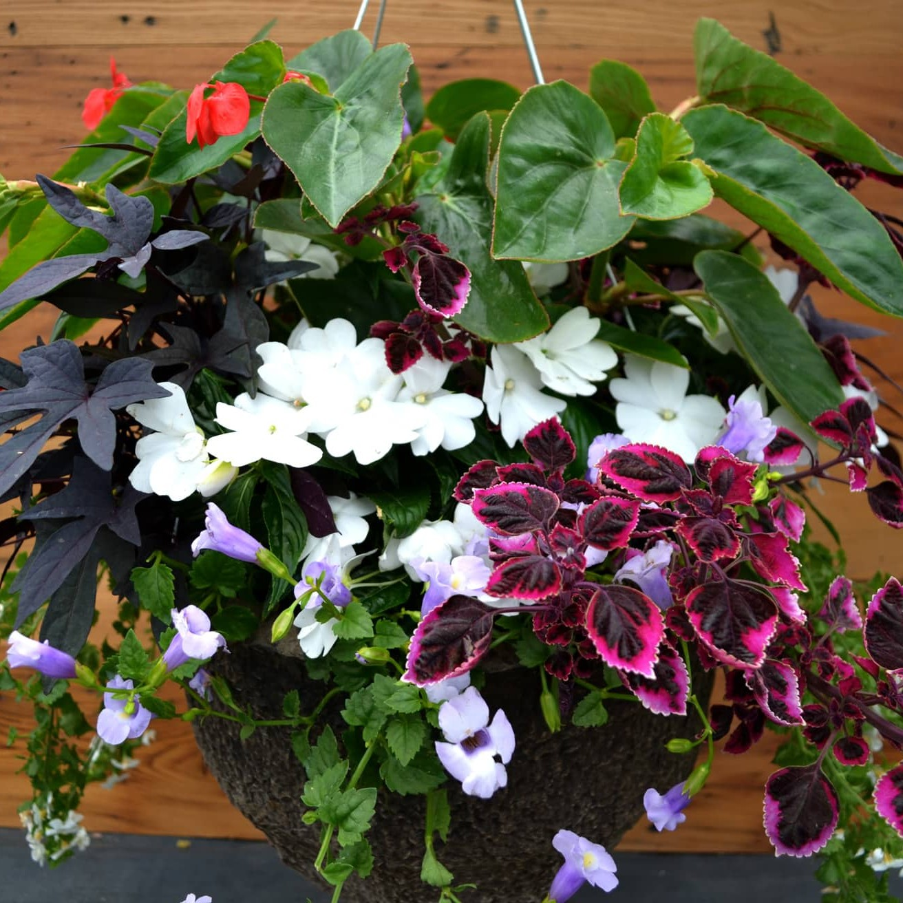
Adventurine Blue Lagoon Riptide

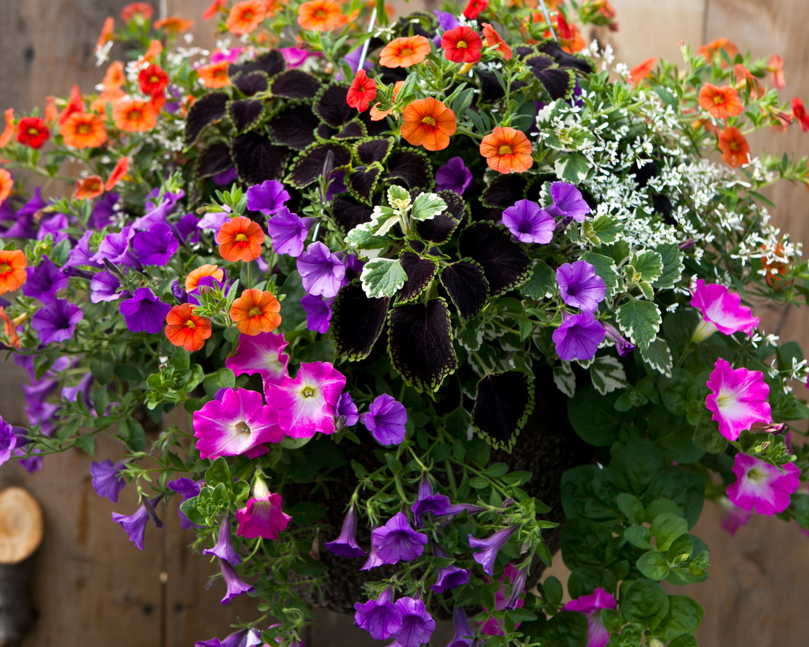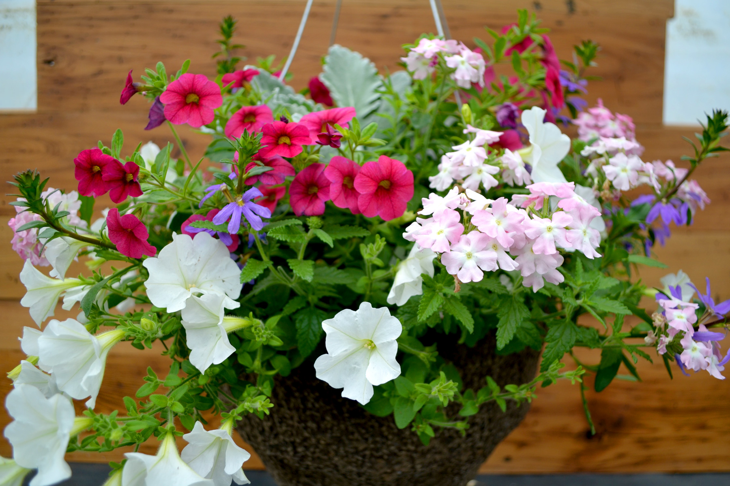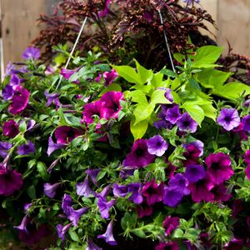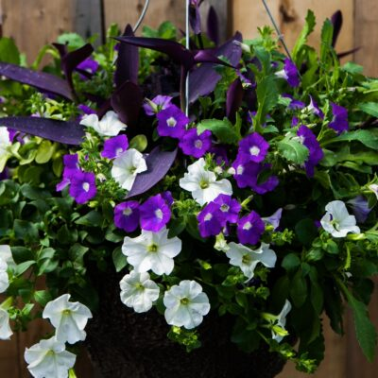
Spring Meadow Sun Showers Trade Winds Twilight

12” Baskets
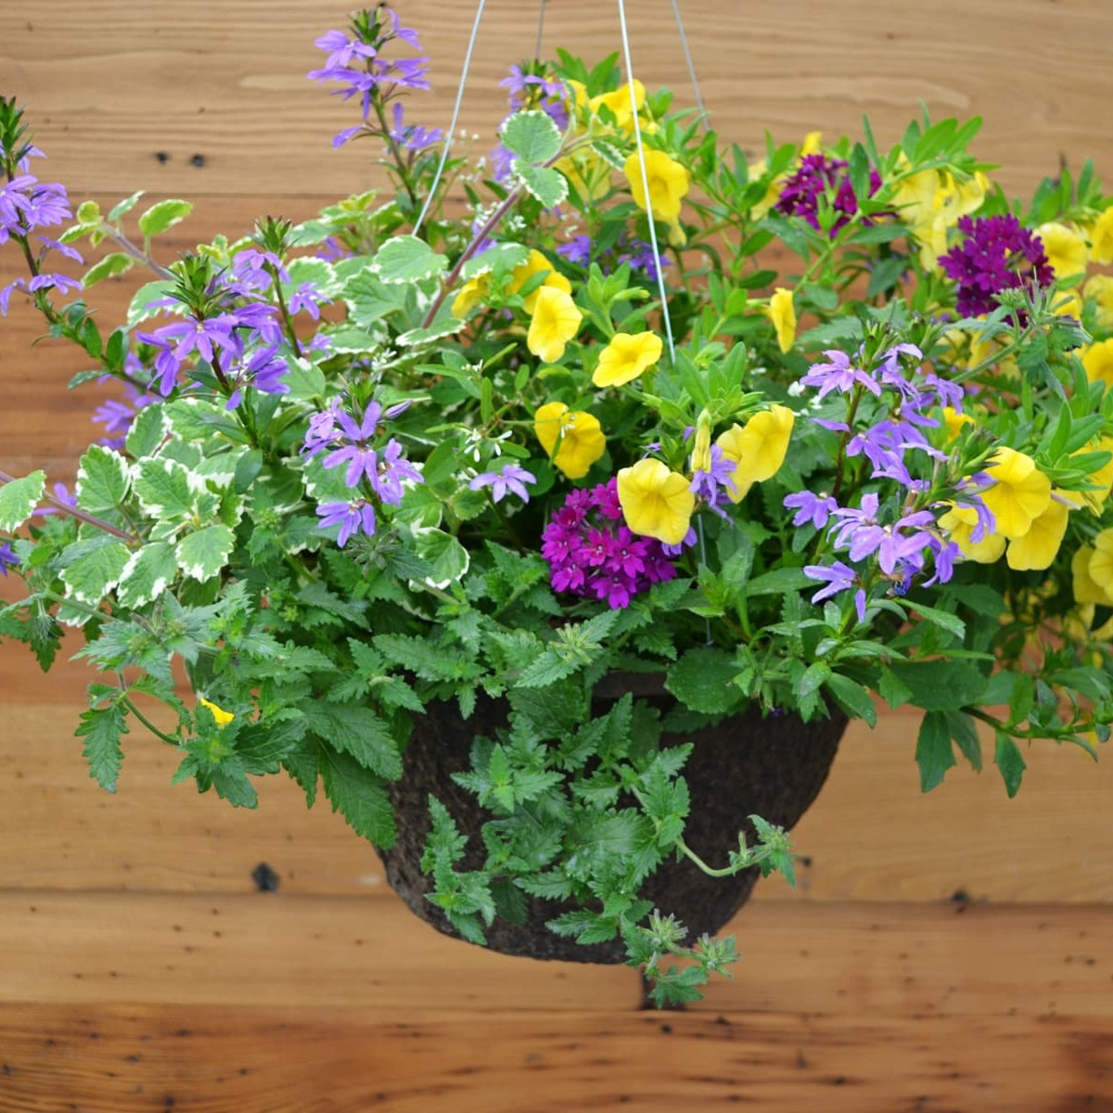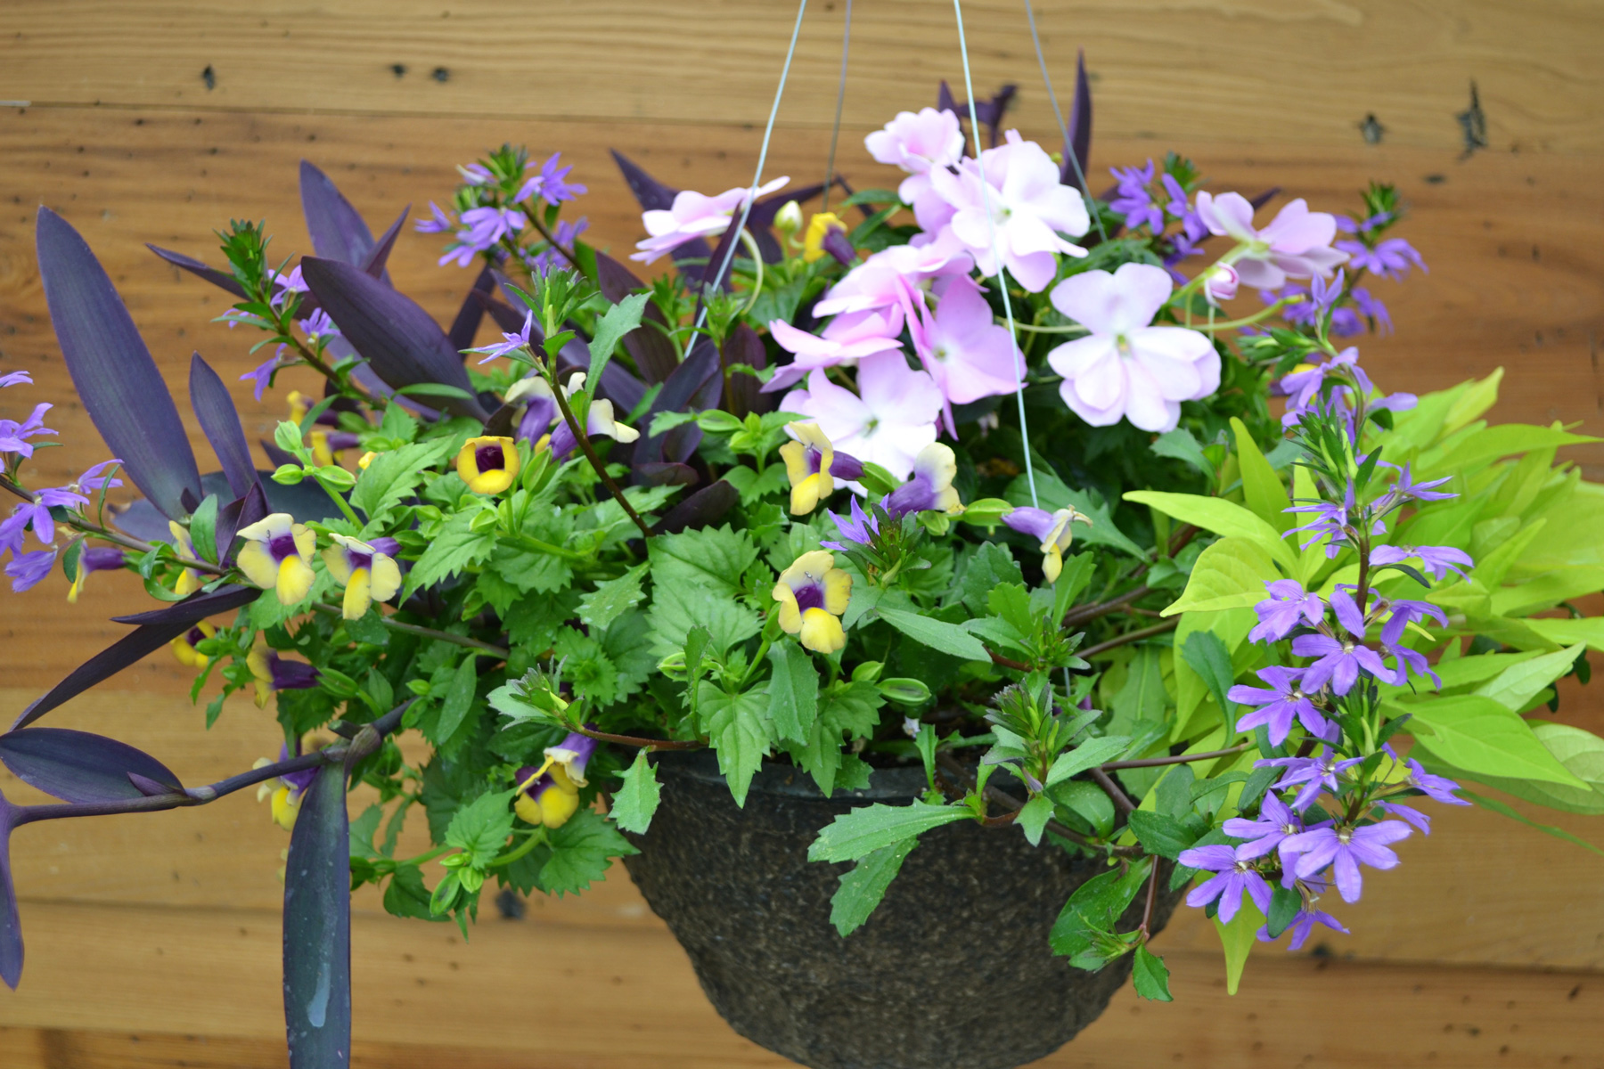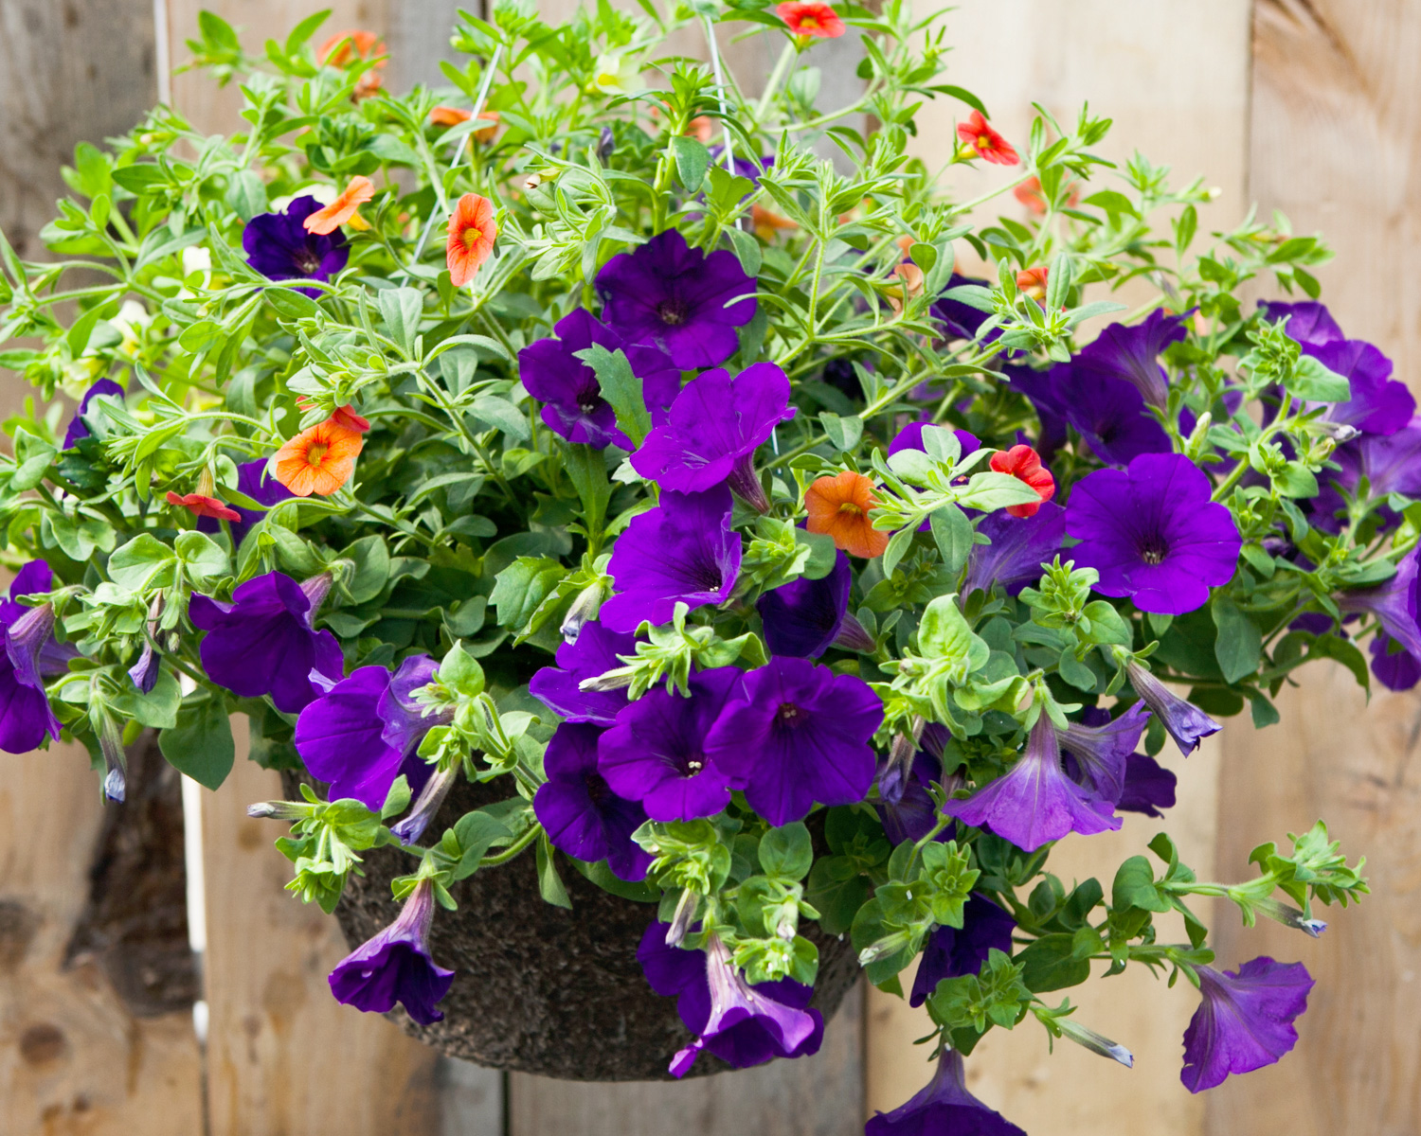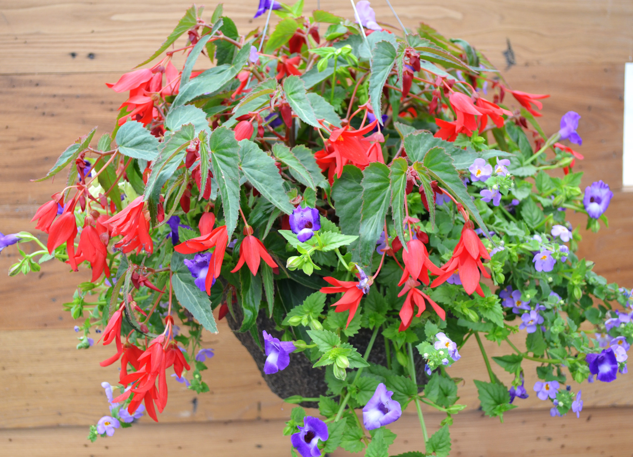
Appalachian Trails Bombay Hook Denali Petra
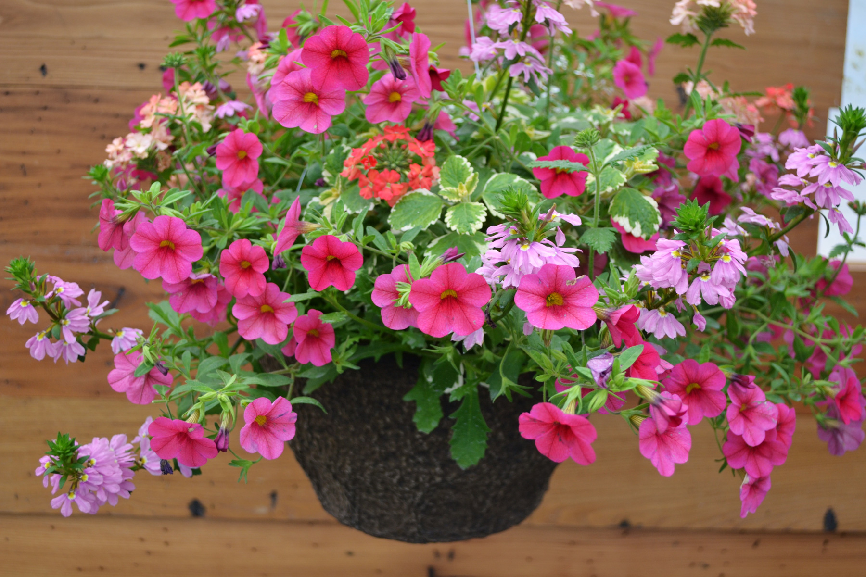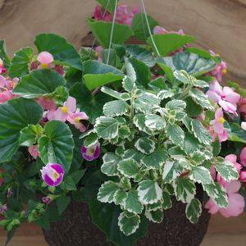
Sedona Zion Pink \

This Year’s Winning Bedding Plants

Beds & Borders offers many single plants. We have explored their list and chosen these to offer as potted single bedding/container plants. Pot size – 1 quart
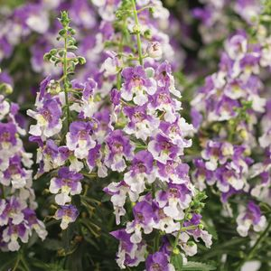
Angelonia Angelface
Wedgewood Blue; Sun; 18-30" x1 2-18"; Upright
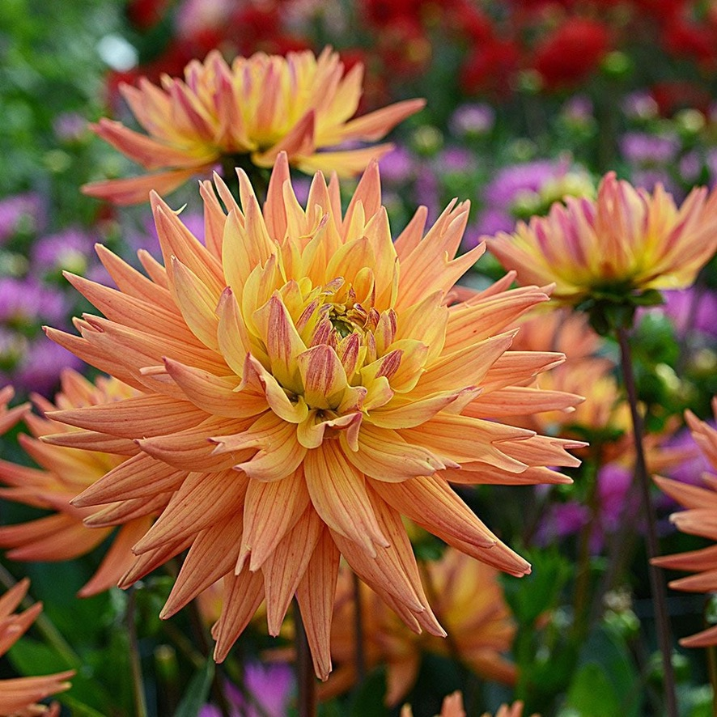
Dahlia Karma Corona; 24-36"; Zone 7-10; 8" pot

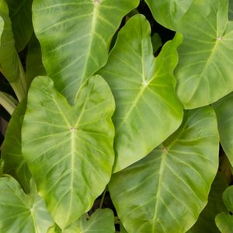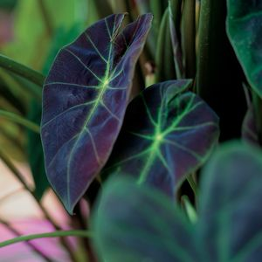
Colocasia e. Maui Gold; 24-36" x 12-18"; Part Shade-Shade

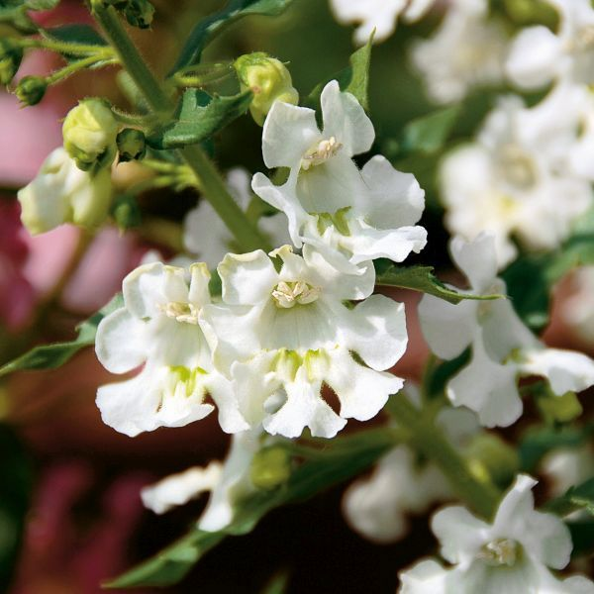
Angelonia Angelface
White; Sun; 12-14" x
12-18"; Upright

Colocasia e. Illustris; PS-Shade; 24-36" x 12-18"; Upright
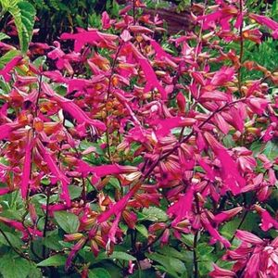
Salvia Wendy's Wish; Sun; 36-48" x 24-36"; Upright
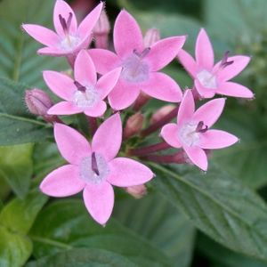
Pentas Abby; Sun; 18-24" x 10-18"; Upright

Pentas Northern Lights;Sun; 18-24" x 10-18"; Upright
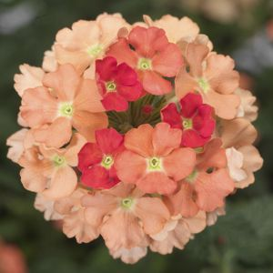
Verbena x Lanai Peach; Sun; 4-10" x 12-20"; Trailing

Bedding Plants

Name | Light Req. | Price | # pots | Total $
Angelonia AngelFace White | Sun | $8
Angelonia Wedgewood Blue | Sun | $8
Colocasia e. Maui Gold | PS-Shade
Colocasia e. Illustris | PS-Shade
Dahlia Karma Corona | Sun | $8
Salvia Wendy’s Wish | Sun | $8
Verbena x Lanai | Sun | $8

Total $ _________

Payment Details
Add up totals from Collections, Baskets and Plants $______
Add $ 3.00 if paying with Venmo $______
Total amount due $______

The deadline for ordering is , 2024. But the sooner, the better!

Delivery will be in early May and require you to come pick up your plants at a convenient location in Paoli.

Check: Please make out checks to The Weeders and mail (with your order form) to Ellie Penniman, 600 Cathedral Rd., B-203, Philadelphia, PA 19128

Venmo: On the app, find and pay @theweedersgardenclub. In the “What’s it for” section, please type your full name. Please add $3 to cover Venmo’s service charge. Mail your order form to Ellie Penniman.

Credit Card: You can place your order online at www.theweeders.org. Note that prices are slightly higher online to cover the cost of credit card fees. There is no need to mail in an order form if you are ordering and paying online!

Don’t Forget: If paying by check or Venmo, your printed order form must be mailed to

Ellie Penniman
600 Cathedral Rd., B-203
Philadelphia, PA 19128

